Lakeway 04 21 2024

S.H.A.P.E

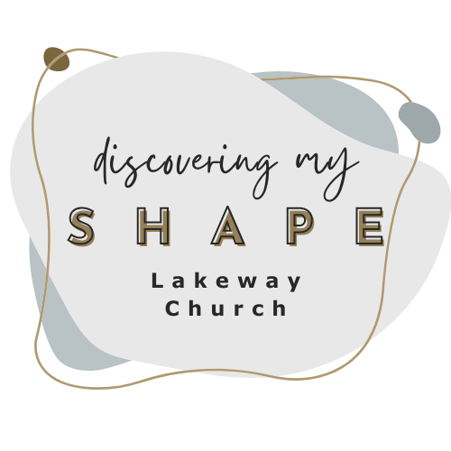
For we are God’s masterpiece. He has created us anew in Christ Jesus, so we can do the good things He planned for us long ago. Ephesians 2:10 (NLT)

The Spirit is a ______________
⁸ The wind blows wherever it wants. Just as you can hear the wind but can’t tell where it comes from or where it is going, so you can’t explain how people are born of the Spirit.”
John 3:8 (NLT)

The work of the Spirit:

- To ___________________ us

- To ___________________ us

- To ___________________ us

Seven Facts about the Spiritual Gifts:

- ________________ has one
- They are to be used to ________ and ___________ community
- They are to be used in _________
- They are to be _______________
- They _______________ you
- They are used to bring ________ to God
- They will __________ ___________

Next Steps:

- Pray
Lord I want to be used of You
Show me how you want to use me
Give me the courage to seek your way in my life
Please use me
- Get in Shape (Join a class)
Discover your Spiritual Gifts

